الاسم : عمر محمد محمود حسنين (2)
Chapter 1
- Write about two of the philosophy of python :
-beautiful is better than ugly: in python the coding style is designed to be as readable and easy as it could be.
-flat is better than nested: in python using nested function isn’t recommended and it is preferred to use flat code.
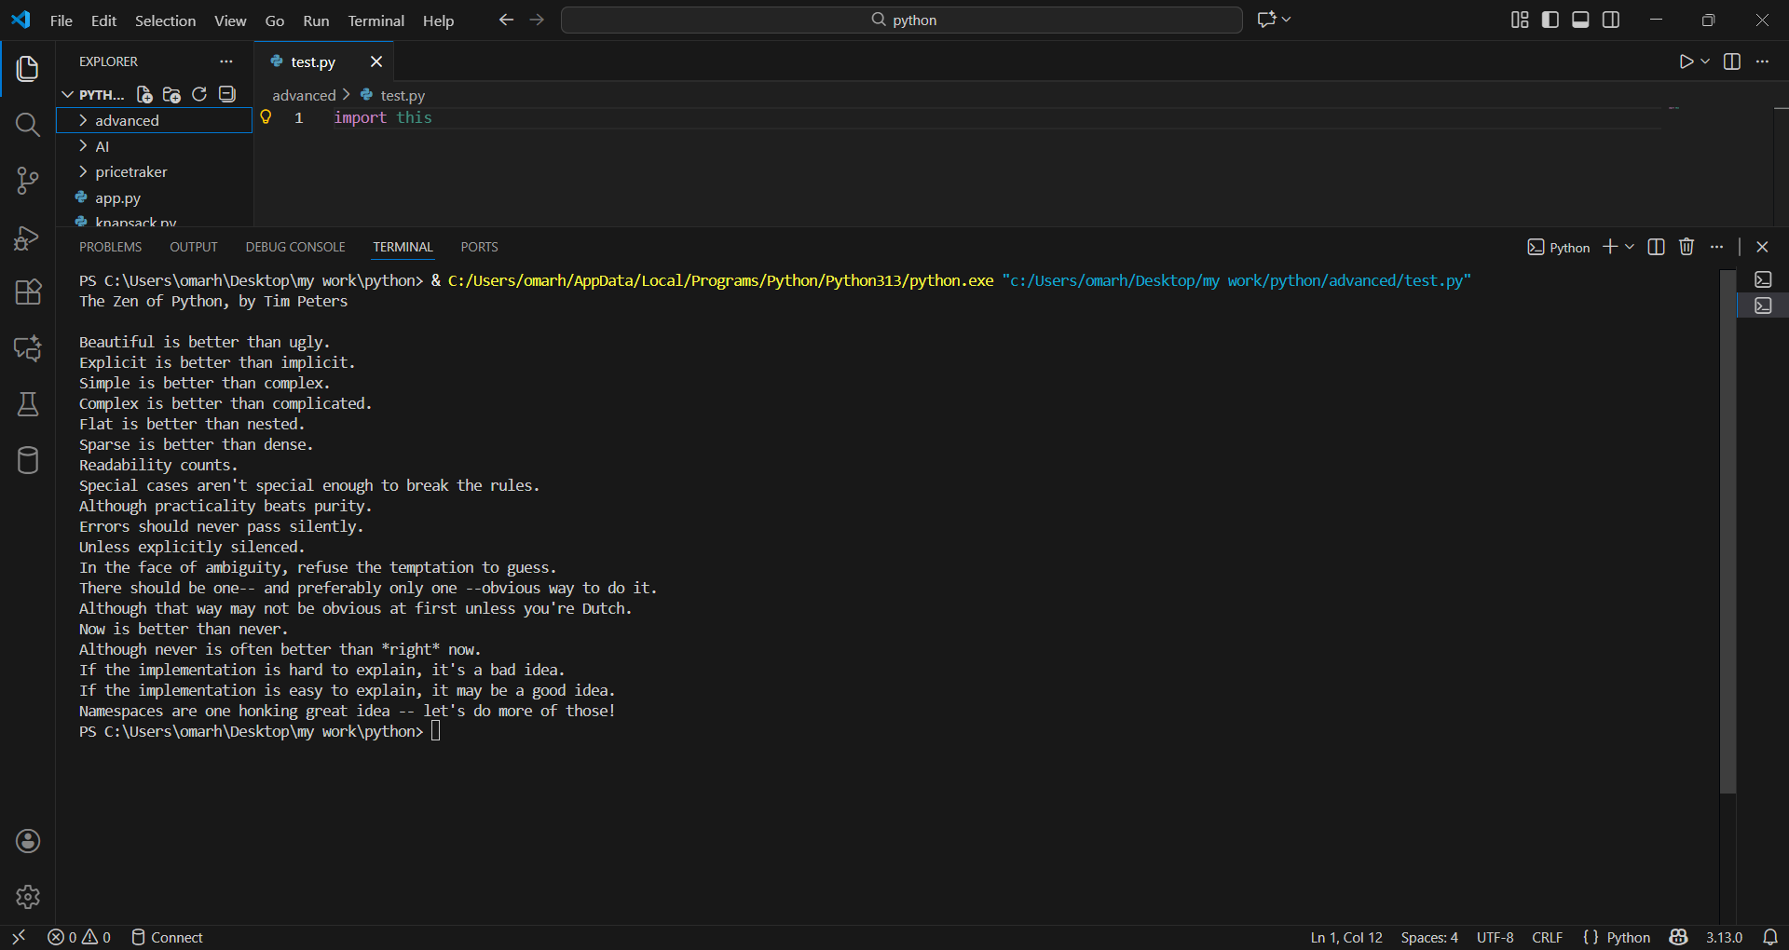
2)
-bytecode instruction correspond multiplication operation is: BINARY_OP 5 (*)
-in binary add instruction the bytecode was : BINARY_OP 0 (+)
-add function vs multiply function bytecodes:
-similarities: LOAD_FAST_LOAD_FAST 1 (a, b),
RETURN_VALUE
-differencies: BINARY_OP 5 (*) in multiplication
BINARY_OP 0 (+) in addition
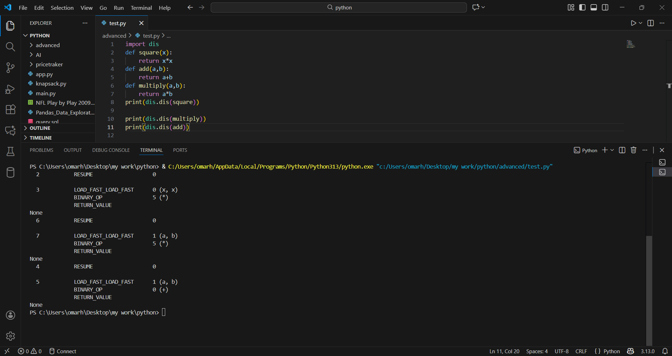
3) 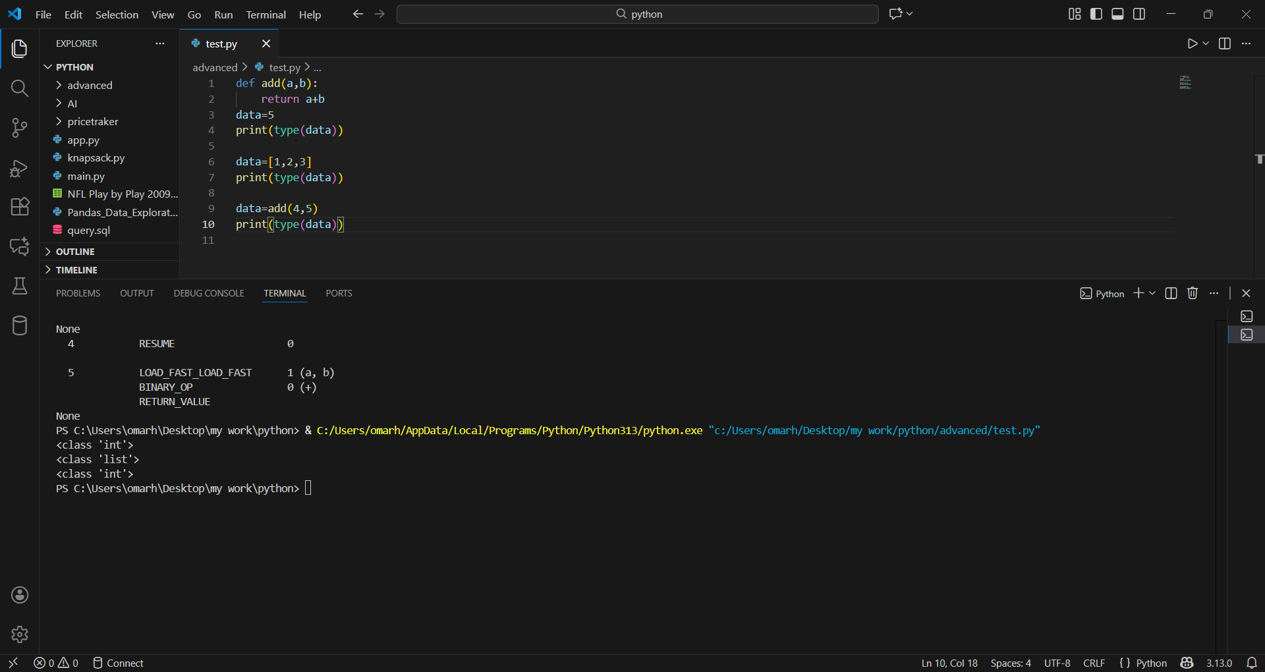
4) pypy: in a python interpreter which is very fast as it use JIT complier it is useful for cpu complex tasks but it is not compatible with some libraries like numpy which runs slower.
Cpython: it is the most widely used python interpreter,it complies the code then use PVM to execute it.
Jython: it is another python interpreter that uses JVM to execute the code which makes it capable of using java libraries and make python-java programs.
5)node that specifies multiplication : op=Mult()
Node that specifies subtraction: op=Sub()
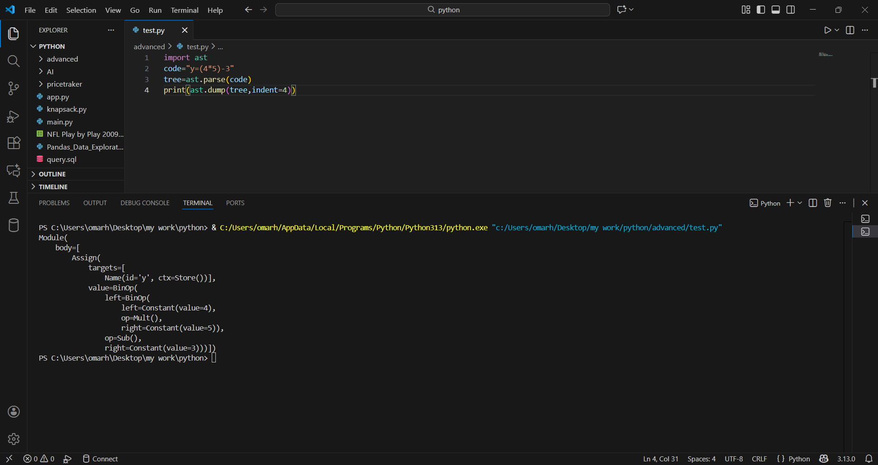

6) python list address doesn’t changed.
-python list in mutable that can be changed after creation while other immutable object like tuple can’t be change after creation so, when adding a value to it, it is saved in another memory location as a new variable.
